EXPERIMENT 13
You are tasked with developing an Online Learning Platform. The
platform should include the following functionalities:
1. Course Enrollment and Registration
2. Video Lecture Streaming
3. Interactive Quizzes and Assignments
4. Progress Tracking Dashboard
5. Peer-to-Peer Discussion Forums
6. Certificate Generation
Use Jira to categorize and prioritize these requirements using
MoSCoW and Kano techniques.

Step 1:Open jira and select space and click on scrum
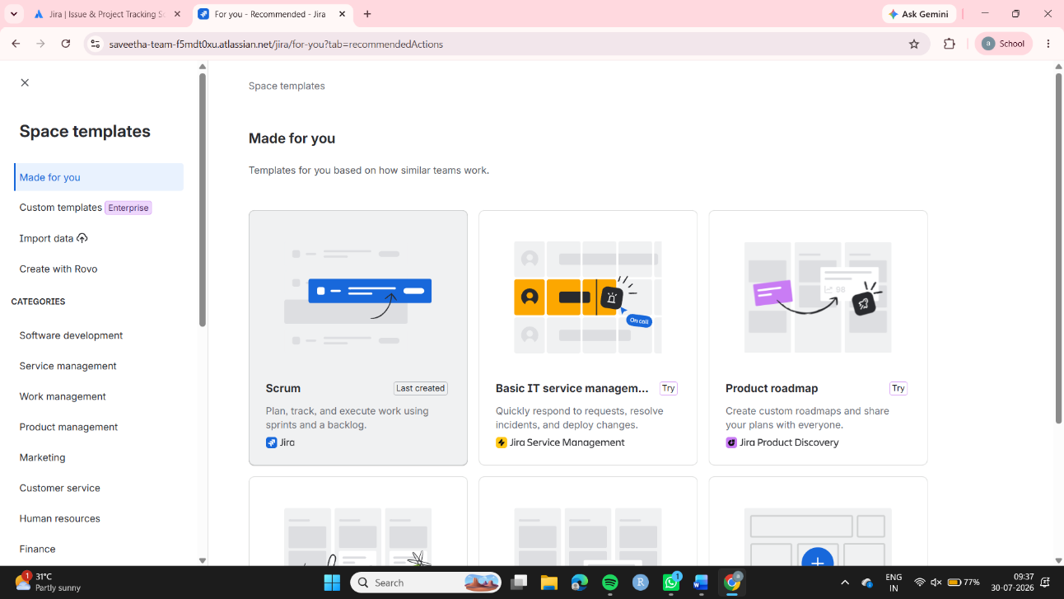

Step 2: Then fill all the details in Name your space and create
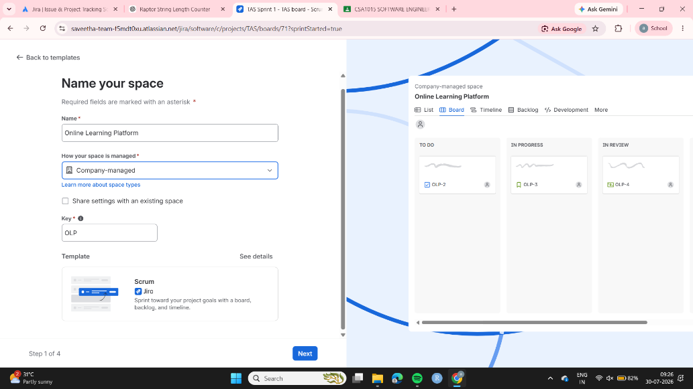

Step 3:In the homepage open settings and select Work items
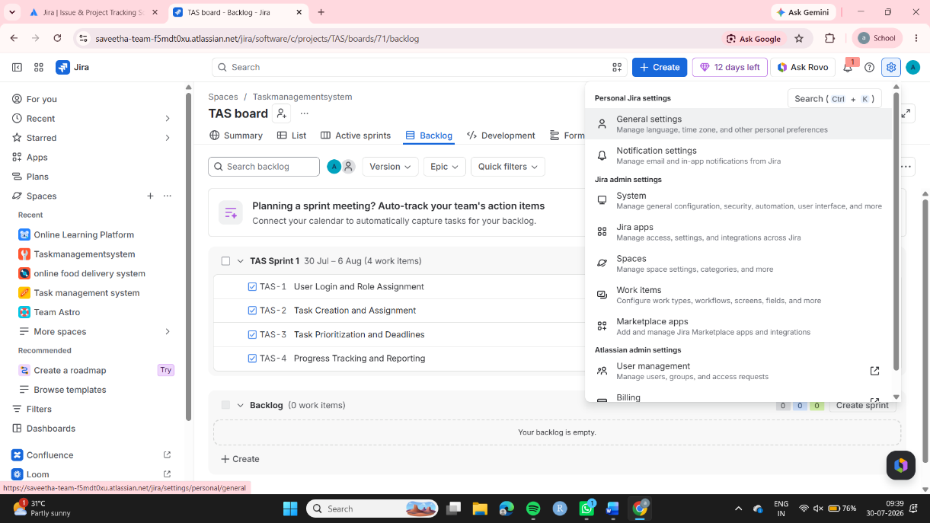

Step 4:Then click on the Priorities and change the priorites like this and check the priority schemes ,if they are updated move to home page
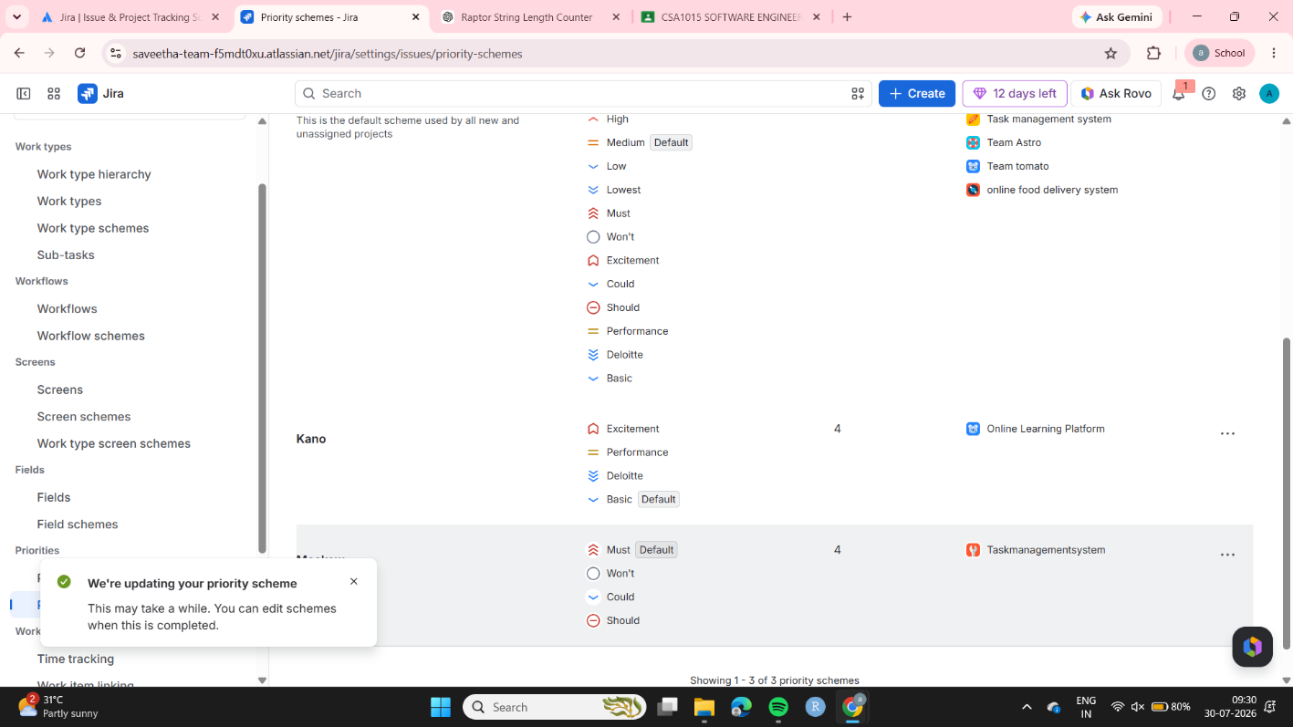

Step 5:Assign the tasks in the backlogs and assign the team members and change the priority and click on start sprint
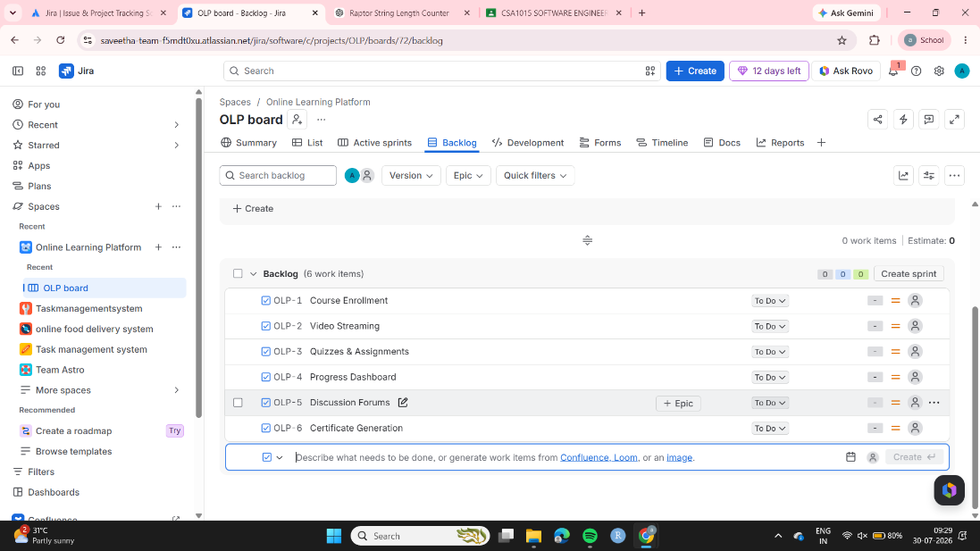

Step 6: Then all the tasks will be moved to TODO
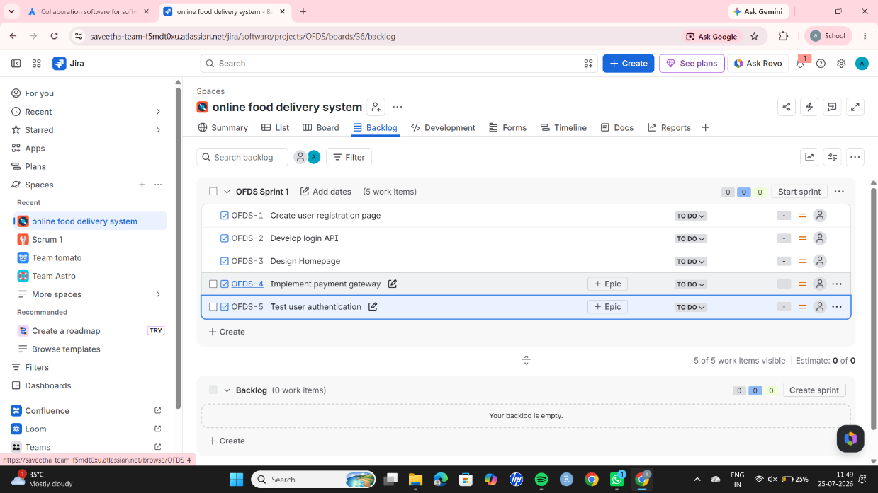

Step 7: Then move the tasks according to the workdone
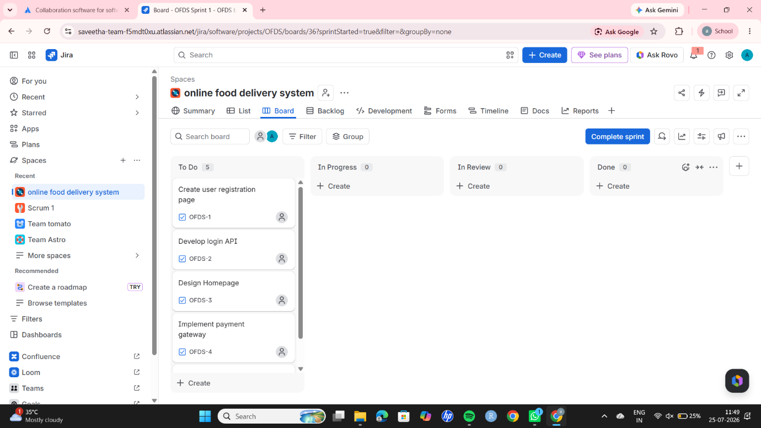
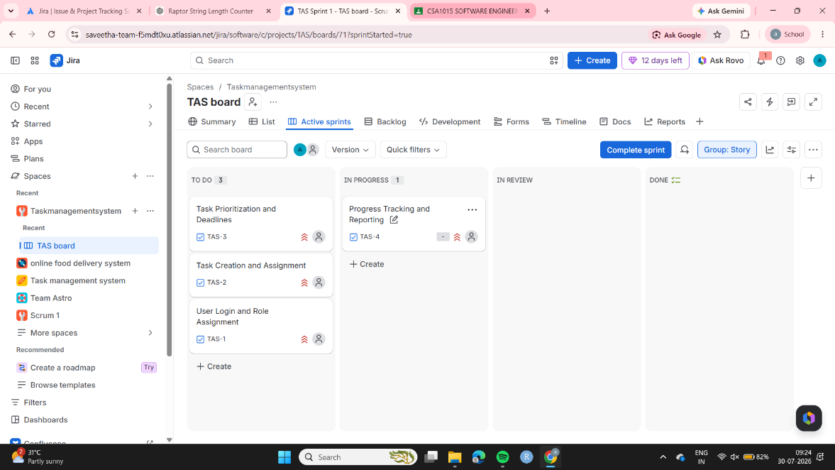

Step 8: Once all the tasks are finished move to LIVE
